Maze Game Guide

Welcome to Mr. Dwyer’s guide to building your own Maze Game inside of Visual Basic, using Visual Studio.

PART 1: Designing the Maze
Designing the maze is a simple task. Using the PictureBox tool draw your maze using multiple PictureBoxes, colour the PictureBoxes representing the walls the same colour (I have used dark green in my example) and name them ‘w1’,’ w2’ and so on. Build a maze similar to the following:
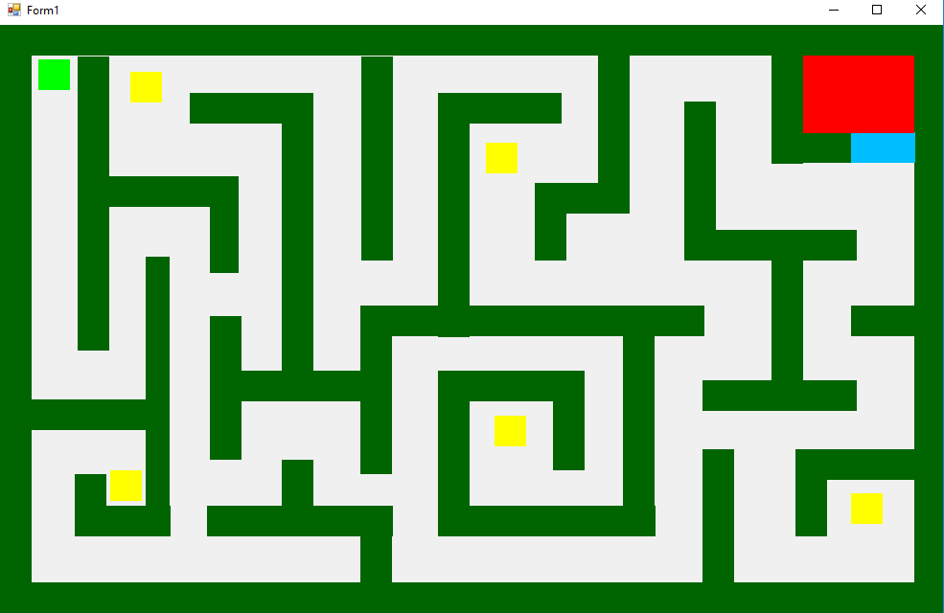
Dark Green PictureBoxes are walls, there is 42 of them in this example. Yellow PictureBoxes are collectables, place 5 of these in your maze, name them ‘Collect1’, ‘Collect2’ and so on. Place a Blue PictureBox in a location that blocks the player from entering and area, this will be a gate. Name the blue PictureBox ‘Gate’, behind the gate place a red PictureBox called ‘Goal’. Finally the FluroGreen PictureBox is our player, call this PictureBox Player or Bob (I have used Bob in this example).

Continued Next Page.

PART 2: Programming Movement
To add movement to our player character ‘Bob’ double click anywhere on the form to open the codeing area. Delete the generated Private Sub and replace it with the following code.
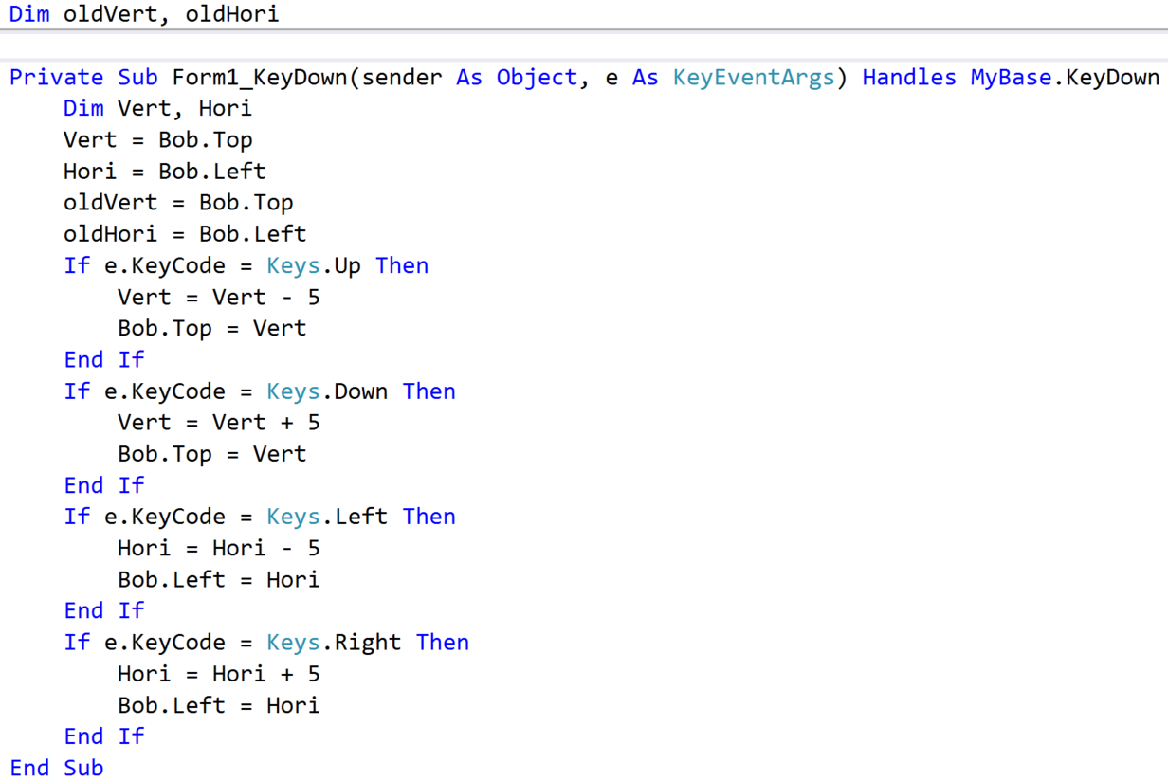
This Sub Routine activates when the user types on the keyboard. When activated several things happen. Two new Variables are created, Vert and Hori and the current horizontal and vertical location of Bob is saved in them. Next a copy of these locations are saved in oldVert and oldHori (These are used later). Finally the Sub Routine checks to see what key on the keyboard was actually pressed, if the pressed Key was either, Left, Right, Up or the Down Arrow the corresponding if statement is activated.
The if statements manipulate the values of Vert or Hori depending on which key was clicked. If the Right Key was pressed Hori has 5 added to its value, and then Bob’s Left value is set as this new Hori value, moving Bob Right by 5 pixels.
Run your game to see if Bob can move.

PART 2: Programming Collision Detection
In our maze game we do not want Bob to be able to walk through walls. To stop Bob from doing so we need to add in collision detection. To do so, create a new Private Sub called CheckWall(), and add the following code.
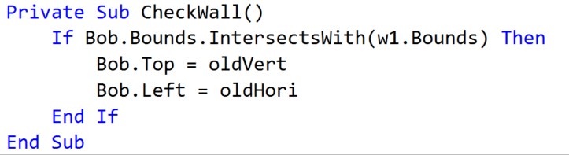
This code checks to see if Bob has entered the space of w1 (if you did not name your walls w1, w2.etc please do so now) and if it does it resets Bob to his previous position using oldVert and oldHori, two variables we set earlier.
This if statement will need to be repeated for each wall you have created and should look similar to the following:
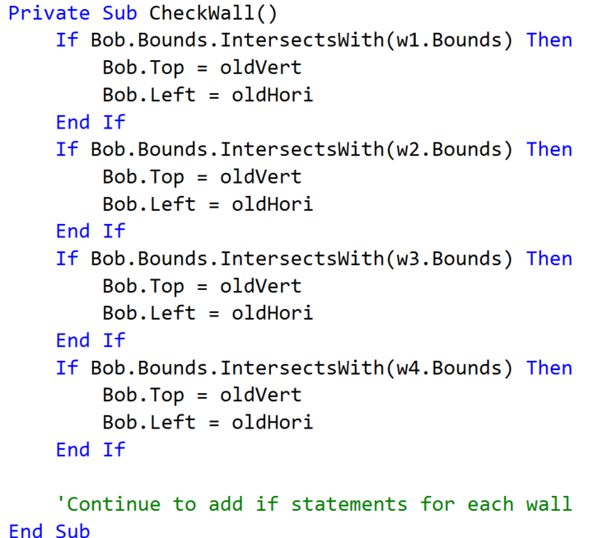
Add in one additional line to stop bob walking through PictureBox Gate.
Finally we need to activate this wall check. In the previous movement private sub Form1_KeyDown add the following code to activate CheckWall():
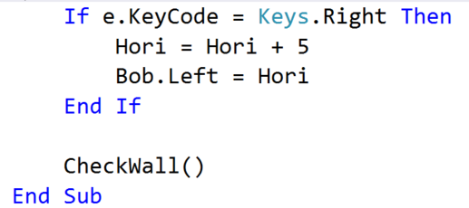
Run your game to check that Bob cannot walk through walls.

PART 2: Programming Collectables and Winning
To win the game Bob needs to make it to the goal (the Red area in the Maze), to do this he needs to pass through the Gate (the blue area). The gate will be opened when Bob collects the 5 yellow collectables throughout the maze.
To do this we will need a new variable called TotalCollected, declare this as an integer and set it to 0 at the start of your program like so:
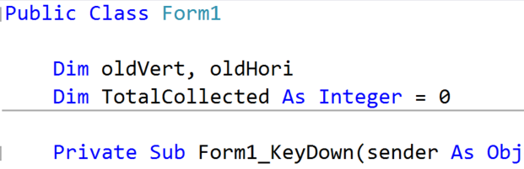

Continued Next Page.
Next create a new Private Sub after CheckWalls called PickUpCollectables(). Add in the following code:
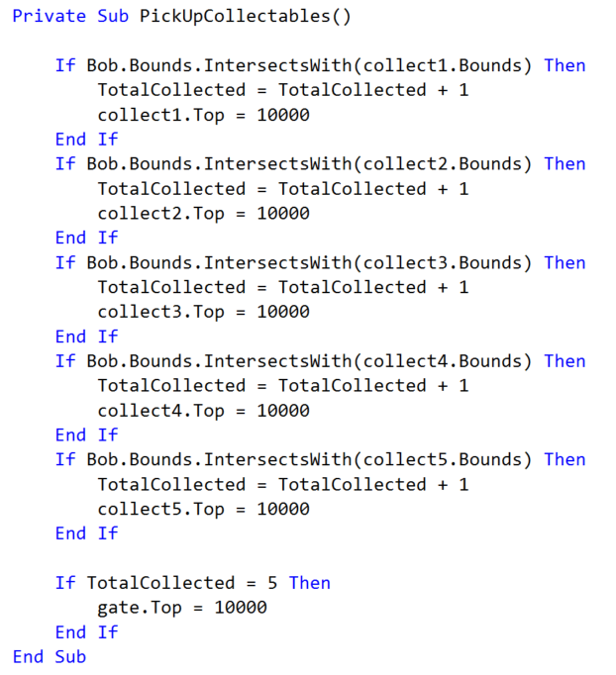
This code checks to see if Bob is standing on one of the Collectables (if you have not named your collectables collect1, collect2.etc please do so now). If he is the collectable is removed from the game Area (Placing it 10,000pixels away) and the value of TotalCollected is increased by 1. When TotalCollected reaches the value of 5, the gate is moved allowing the player access to the goal.
In wall detect add the following:
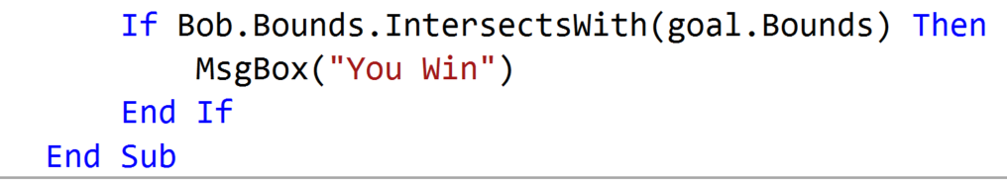
With this] piece of code when Bob touches the goal he is declared the winner of the game. Finally activate PickUpCollectables() just after CheckWall() in Form1_KeyDown.
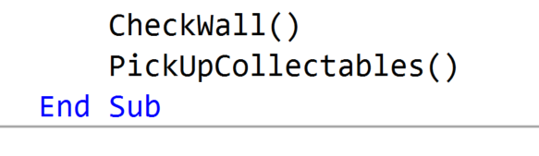
Enjoy your Game!

