YEAR 9 DT
Muppet Face

Welcome to your first Visual Basic Programming Task. In the following task you will create a program that will build our Muppet Face when the user clicks certain buttons.
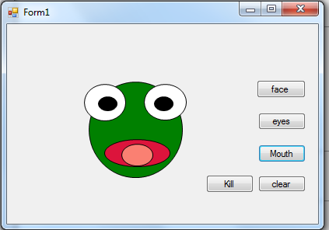

INSTRUCTIONS
- Open Visual Studio. You can find visual studio by typing VS while you have your start menu open in Windows 10.

- Start a new Project by going to File > New Project. Make sure Windows Forms Application is selected. Name your project “Muppet Face” and browse to a location in your work area where you would like to save it. Hit save.

- We need to draw the first part of our Muppet Face. In Visual Studio to the left you will find an area labelled Toolbox. Click This. Your new Toolbox area will appear. Click the pin icon in the new area to keep your toolbox open.

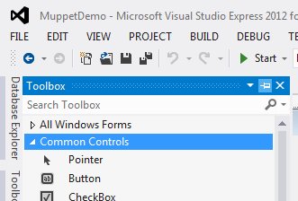
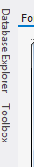

- In this area find “Visual Basic Power Packs”. This will give you more tools to work with. Find the oval tool.

- In your work area, draw an oval. This will be the basic shape for your Muppet Head.

- On the Right Side of Visual Studio is an area called properties. Read through the properties until you find an area titled Design. Look for the Name attribute, change the name to FaceOVL.
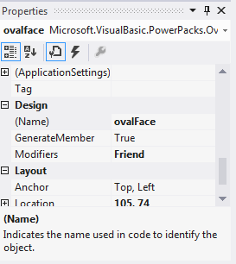

- Look through the properties until you find the appearance area. Click on BackColor and the select the drop down box. Choose a Green like colour for your Muppets face. Also under appearance find BorderStyle and change its attribute from “Transparent” to “Solid”.

- Back in your toolbox find “Button”. Place a Button beside your Oval. Change the Buttons Design Name to “BTNface” and under appearance find the “Text” attribute, change this to say Face.

- Double click the background of your form (The area you have placed your Button and Oval). The Following should appear.

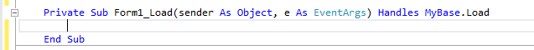

In this area we are going to add our first piece of programming code. Enter the following:

ovalFace.visible = false

By doing this we are chaging the visible attribute of ovalFace to false. Since we have this attribute change in ‘Private Sub Form1_Load’ (code that is executed when we first run the program) our oval will no longer appear.

- Using the tab near the top of the page go back to the form with the oval and button on it. Double click the Button, this will create another area in our code. Add the following:

ovalFace.visible = true

This will set the visible attribute to true when the button is clicked.

- It is time to test our code to see if it works. Click the play button near the top middle of Visual Studio.
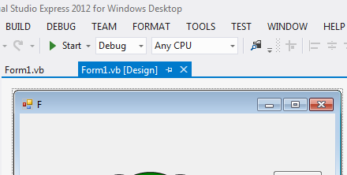

- If it worked the form that appears shouldn’t have anything but the single button on it, but when clicked the oval will appear.
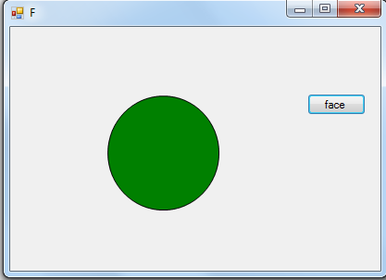
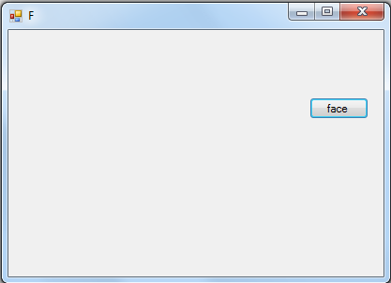

- Close the running program by clicking the X in the top right corner.

- Draw the rest of your Muppet face, It should have two eyes with pupils and a mouth with a tongue similar to the example at the top of this page.

- By repeating these steps add the following Buttons, “Eyes, Mouth and Clear”. Eyes should make both eyes and pupils appear, Mouth should make the mouth and tongue appear and Clear should make everything disappear. Likewise you will also need to set everything to be invisible on load.

- Test your program to see that each button functions correctly.

- Add in a kill button. This Button will make the Muppet face appear dead. You will need to it to change the colour of the main oval and have crosses appear in its eyes instead of pupils. To change colour use the following code:

ovalFace.BackColor = Color.Green

Subsitute Green for the colour you want. Remember to spell colour the American way in the code (color).

Your final product should look similar to the following:

