
Murray Bridge High School
Year 9 Digital Technology
Summative Task 2: Visual Adventure

Your task is to create a visual choose your own adventure game. A choose your own adventure is a style of storytelling where the reader, or in this case the player is given key decisions to make which changes the path of the story, a visual choose your own adventure has images that accompany the story being told.
For Example:
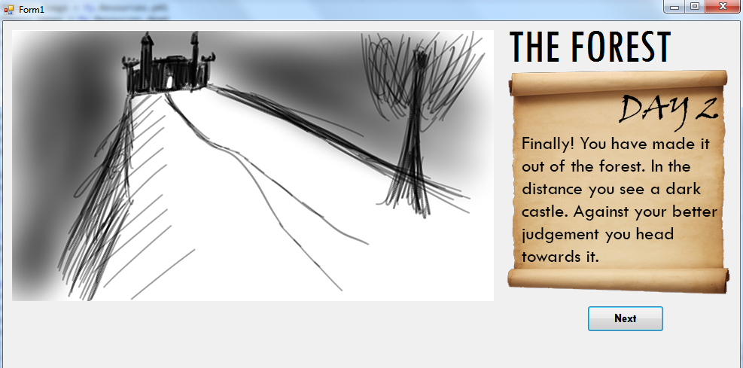

REQUIREMENTS:
- At least three complete story paths
- Images to accompany the story (you do not need to make the images).
- A write up including (approx. 300-400 words):
  - Introduction: explaining the task
  - Design: Plan out your game, both story and gameplay
  - Production: Examples and explanation of your coding
  - Evaluation: including the following
    - Summary of the overall task
    - How well did your final game fit what you planned to make
    - Did you use your time wisely?
    - What did you learn?

- Example of a basic flow chart for my example game:
WINNER IS YOU
DEAD
BEGINNING
SEARCH?
IF PLAYER HAS DAGGER:
DEFEND YOURSELF
CHARGE
RUN AWAY
FIGHT
FIND CASTLE
REST FOR THE NIGHT
FIND DAGGER

SIMPLE AIM
You will need the following:
- A detailed flow chart of the choices you can make in your game
- At least three paths and choices that can be made
- Images that change based on the story

INTERMEDIATE AIM
- Different paths open up based on previous choices (for example the player may gain an item which gives them a new option in certain choices).
- Choices with more than two options

COMPLEX AIM
- Increased complexity, how you do this is up to you. Some ideas you could try and implement are
  - Customizable character with stats
    - Stats effect choices, Strength may mean you can win a fight easier or intelligence could help your character solve a puzzle
  - Text commands as opposed to buttons allowing for secrets (EG, provide the user with what the need to type, but also have secret commands that open up other options).

